**OrderOnTheGo – Final Project Report**

**1. INTRODUCTION**

**1.1 Project Overview**

*OrderOnTheGo* is a MERN-stack based food ordering platform that bridges customers, restaurants, and administrators. Users can browse restaurants, view menus, add items to their cart, and place orders. Restaurant owners can manage their products and orders via a dedicated dashboard, while admins oversee promotions and platform governance.

**1.2 Purpose**

To build a full-featured, real-time food delivery platform with role-based access for customers, restaurants, and admins, while offering intuitive UI/UX and secure data handling.

**2. IDEATION PHASE**

**2.1 Problem Statement**

Many local restaurants and users face difficulties in connecting digitally for food ordering. How might we simplify and digitize the food ordering process for both customers and restaurant owners?

**2.2 Empathy Map Canvas**

**Who are we empathizing with?** Food lovers and local restaurants.  
**What do they see/hear/do/feel?**

* See: Unorganized food listings
* Hear: Delays in orders, lack of trust
* Do: Visit restaurants physically or call to order
* Feel: Frustrated, hungry, or undecided

**2.3 Brainstorming**

Grouped ideas:

* **Customer Experience**: Easy UI, categories, cart
* **Restaurant Experience**: Inventory, orders, login
* **Admin Needs**: Dashboard, promotions

Tips used: tags, grouping sticky notes on Mural.

**3. REQUIREMENT ANALYSIS**

**3.1 Customer Journey Map**

1. Visit homepage → 2. Browse → 3. Add to cart → 4. Login → 5. Place order → 6. Track order → 7. Review

**3.2 Solution Requirement**

See **documentation /Requirement Analysis/Solution Requirements (Functional & Non-functional).docx**Functional: Sign up, place orders, manage products  
Non-functional: Secure, scalable, responsive

**3.3 Data Flow Diagram**

Level-0 DFD includes:

* Users
* Restaurants
* Admin
* System processes: Auth, Cart, Orders, Promotion
* Data stores: MongoDB

**3.4 Technology Stack**

* **Frontend**: React.js
* **Backend**: Node.js, Express.js
* **Database**: MongoDB
* **Security**: JWT
* **Architecture**: 3-tier RESTful

**4. PROJECT DESIGN**

**4.1 Problem Solution Fit**

Matching common needs (ordering food) with a digital, responsive, easy-to-use platform.

**4.2 Proposed Solution**

See Project **documentation/Design Phase/Proposed Solution/ Proposed Solution.docx**  
Key points:

* Role-based login
* Smart product filtering
* Admin dashboard for promotion

**4.3 Solution Architecture**

* User → React frontend
* API calls → Node/Express backend
* Data → MongoDB  
  Supports: modularization, role access, and real-time interaction

**5. PROJECT PLANNING & SCHEDULING**

**5.1 Project Planning**

* 4 Sprints
* Each sprint delivered critical functionality
* Story points, burndown chart, and velocity tracked

**6. FUNCTIONAL AND PERFORMANCE TESTING**

**6.1 Performance Testing (UAT)**

* Secure user registration/login
* Cart and order flow tested
* Restaurant product management
* Admin role validation
* All major test cases passed

**7. RESULTS**

**7.1 Output Screenshots**

*Homepage*:

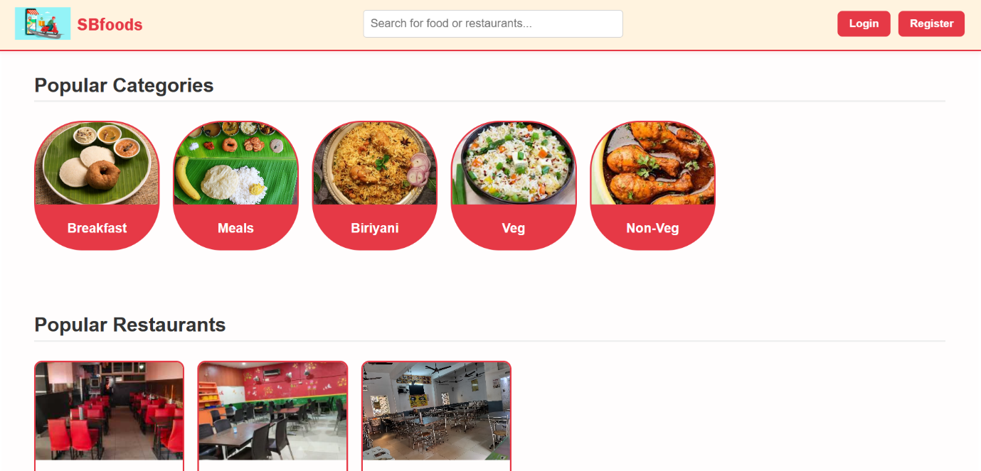

*Restaurants:*

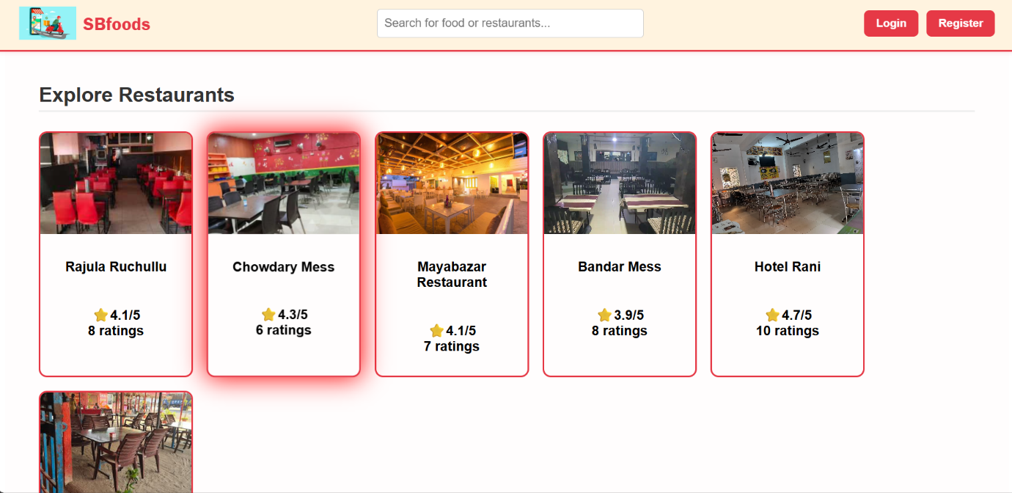

*Cart*:

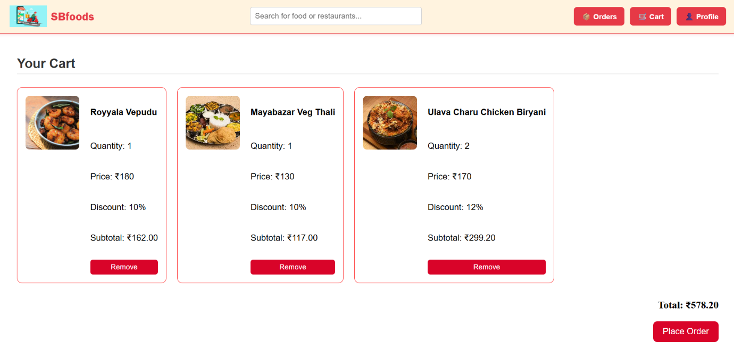

*Orders:*

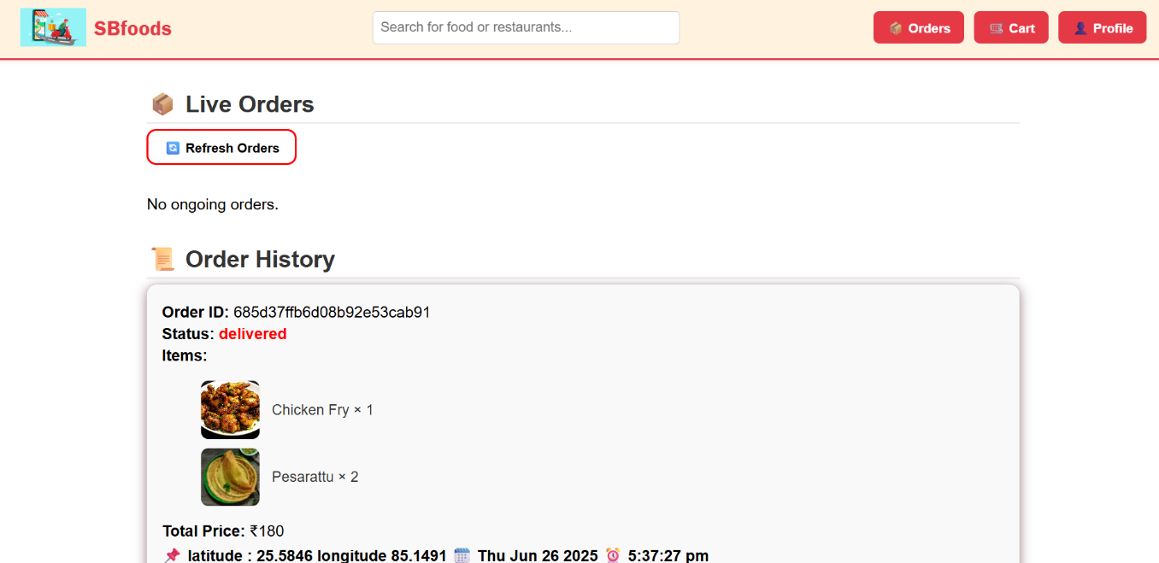

*Restaurant Dashboard:*

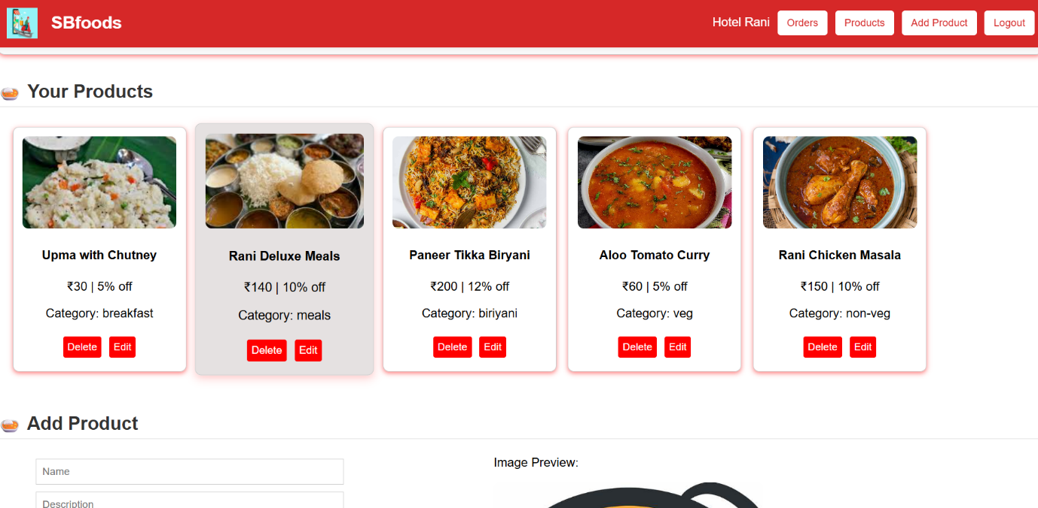

*Admin Dashboard*:

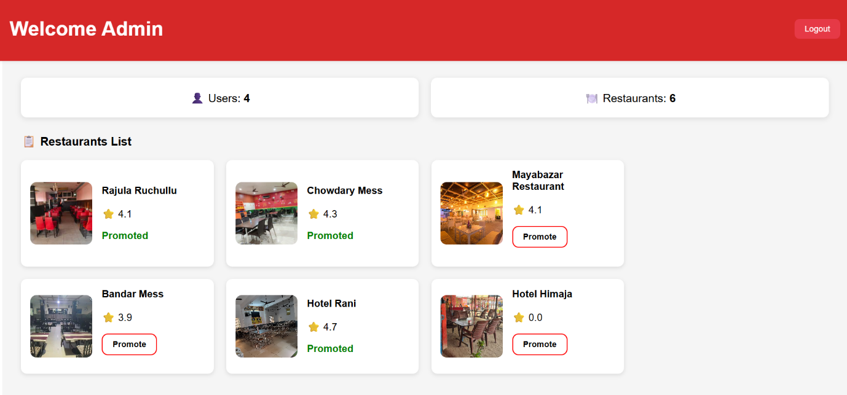

**8. ADVANTAGES & DISADVANTAGES**

**Advantages:**

* Real-time food ordering
* Role-specific dashboards
* Fast & responsive interface
* Secure token-based login
* Admin promotional control

**Disadvantages:**

* No mobile app (yet)
* No real payment gateway integrated (demo version)

**9. CONCLUSION**

*OrderOnTheGo* successfully simulates a real-world food ordering platform using MERN technologies. It showcases authentication, cart logic, admin control, and end-to-end food order management.

**10. FUTURE SCOPE**

* Add real payment gateway (e.g., Razorpay, Stripe)
* Build delivery partner module
* Push notifications for order status
* Launch as a mobile app using React Native
* Add analytics and reports in admin dashboard

**11. APPENDIX**

* **Source Code**: https://github.com/NandiniDoradla/Order-On-The-Go